

Marine Plastic Pollution Classification using Deep Learning

Jekkula Goutham  
 Department of Data Science  
 Atlantic Technological University  
 Email: L00187737@atu.ie

**Abstract**

Plastic pollution in marine environments is a significant environmental problem around the world, posing risks to biodiversity and ecological balance. Plastic trash in underwater environments is difficult to identify and classify due to image distortion, turbid waters, and changing light conditions. The present study seeks to automate the classification of underwater images as 'plastic' or 'non-plastic' based on deep learning methods. This study involves comparative analysis of a bespoke Convolutional Neural Network (CNN) and a ResNet50 transfer learning model with the objective of quantifying performance indicators such as accuracy, generalization, and robustness. The dataset for this study was obtained from Kaggle (SouvikDataset) and comprises more than 2,000 labelled underwater images.

Preprocessing techniques, such as normalization, augmentation, and resizing, were used to enhance the model's performance. Training of both models was done using binary cross entropy, with evaluation being done using metrics like accuracy, confusion matrices, and F1-score. The results show that the ResNet50 model outperforms the baseline CNN when it comes to classification accuracy, in addition to having better generalization properties. This project is part of the emerging area of environmental artificial intelligence, providing efficient and scalable approaches to real-time marine pollution detection.



1.**Introduction** Marine plastic debris has developed into a significant environmental concern in the past few decades. Plastics, with their persistence and low price, have entered all locations, but their presence in marine environments is causing vast harm to marine life. The animals confuse plastic waste with food, and as a result, ingestion, entanglement, and mortality take place. Also, plastics break down into microplastics, which not only enter the food chain but also become a risk to human health subsequently.



 Traditional plastic pollution monitoring methods, i.e., manual collection or satellite imaging, are limited by cost, resolution, and scalability. Recent advancements in machine learning and computer vision present an opportunity to upscale and automate pollution detection. In this project, we plan to implement a deep learning model using Convolutional Neural Networks (CNN) and a ResNet50 architecture to predict sub-merged images as containing plastic or not, facilitating quicker and more effective marine surveys.

**2. Area of Research**

This project is a subclass of environmental AI, which uses artificial intelligence to solve sustainability and ecological issues. Because it uses neural networks to understand underwater imagery, it is especially at the nexus of deep learning, computer vision, and ocean biology. It serves as a practical illustration of how cutting-edge AI methods can be used to support environmental policy and monitoring.   
This initiative also advances image categorization as a field of study within the broader machine learning environment, especially in challenging domains like underwater imagery. These circumstances complicate traditional algorithms by adding noise, vision impairment, and lighting irregularities. Deep learning models are well-suited for these applications because of their ability to generalize in the face of such variability.

**3. Importance of the Work**

The management of marine pollution and attempts to safeguard the ocean are directly improved by this work. Environmentalists and government agencies may be able to take swifter action during cleanup efforts if plastics that have been submerged are accurately and promptly identified. Additionally, identification automation effectively removes the need for manual verification, which is often costly and uncommon and can be laborious or deceptive.   
The experiment also shows a scalable method that may be adapted for use in underwater robots or drones for real-time surveillance. With artificial intelligence (AI) playing a significant role in long-term sustainability initiatives, this technology can aid in the development of smarter oceans at a time when pollution and climate change are the top worldwide concerns.

**4.Aims and Objectives**

The project's overall goal is to develop an effective classification model that can differentiate between images containing plastic waste and those without. This entails the development of an in-house custom CNN model from scratch and fine-tuning a pre-trained ResNet50 network for comparison of performance and generalizability. The specific aims are to:

•Conduct exploratory data analysis and understand the dataset’s balance and variability.

• Apply appropriate data augmentation and preprocessing methodologies.

•Train and test models with accuracy, precision, recall, and F1-score.

•Recognize issues such as overfitting or class imbalance and mitigate them using strategies like dropout, transfer learning, or weighted loss functions.

**5. Dataset Description**

The Kaggle dataset, SouvikDataset, has more than 2,000 underwater photos that have been classified as "Plastic" or "No-Plastic." In order to replicate actual underwater conditions, images also differ in terms of lighting, background clutter, and object visibility. It is appropriate for supervised learning procedures because the images are separated into training and testing folders. The dataset's diversity is one of its strong points, but it also has clear-water landscapes and photos with muddy or sediment-filled backgrounds. This diversity ensures that generalized features can be learnt by models trained on this data. However, it also has issues like noise and class imbalance that require careful attention through augmentation and preprocessing methods.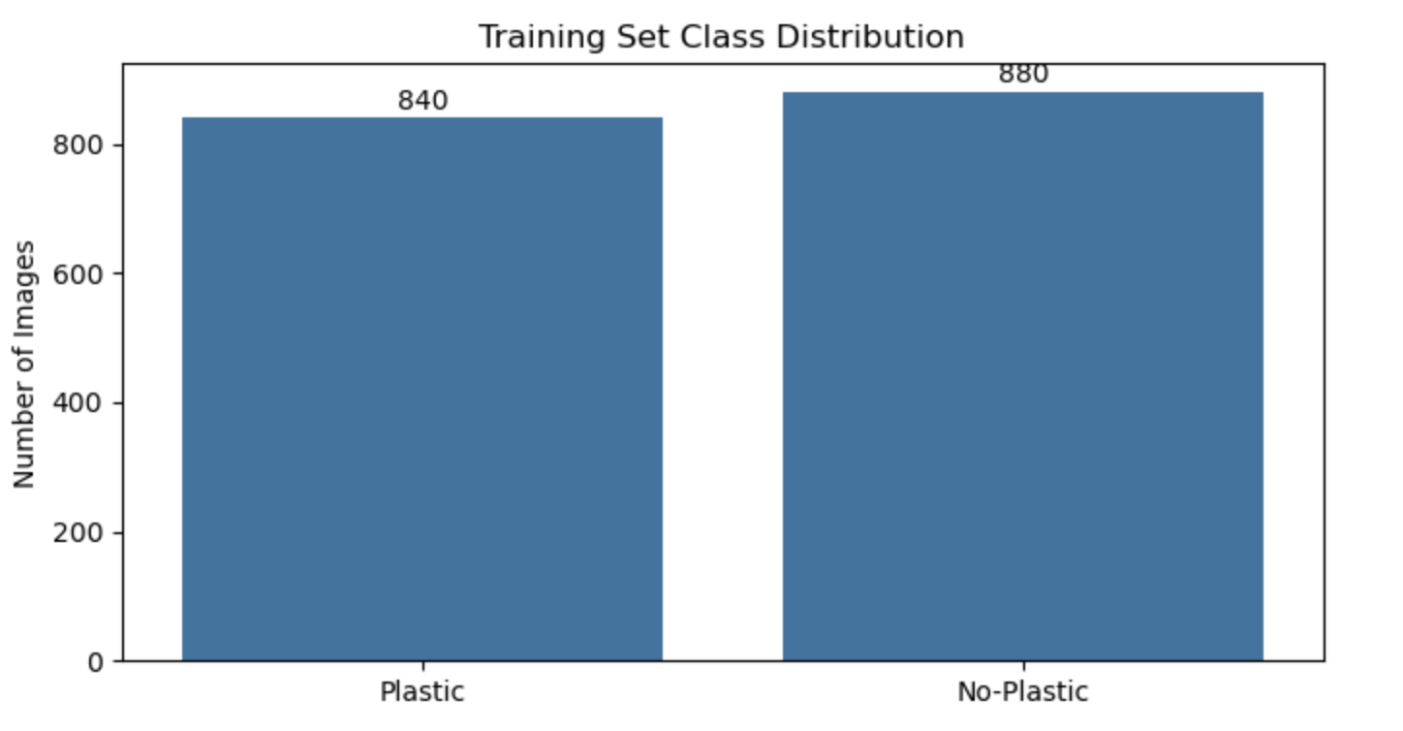

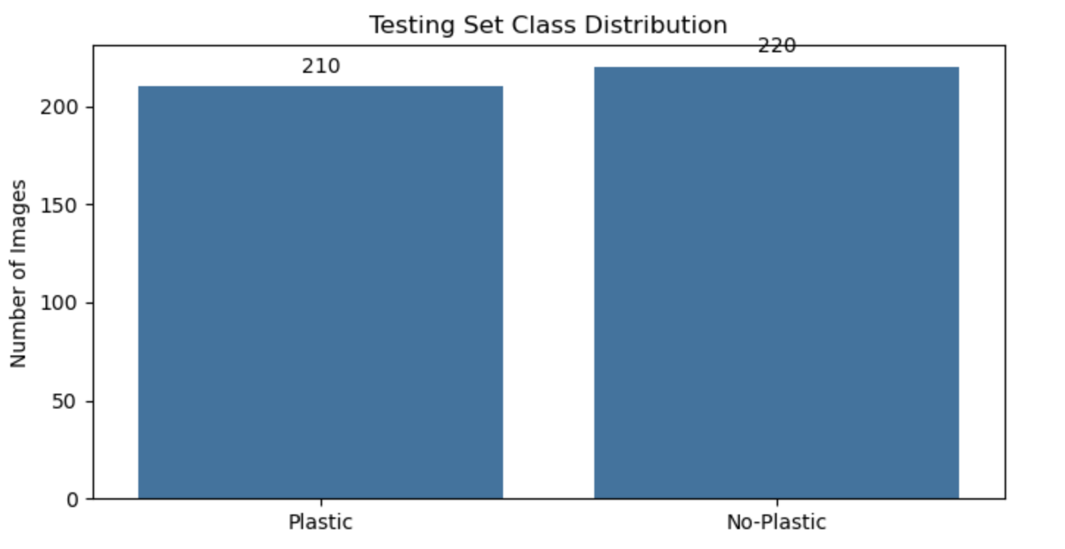 **Sample images from the dataset:**

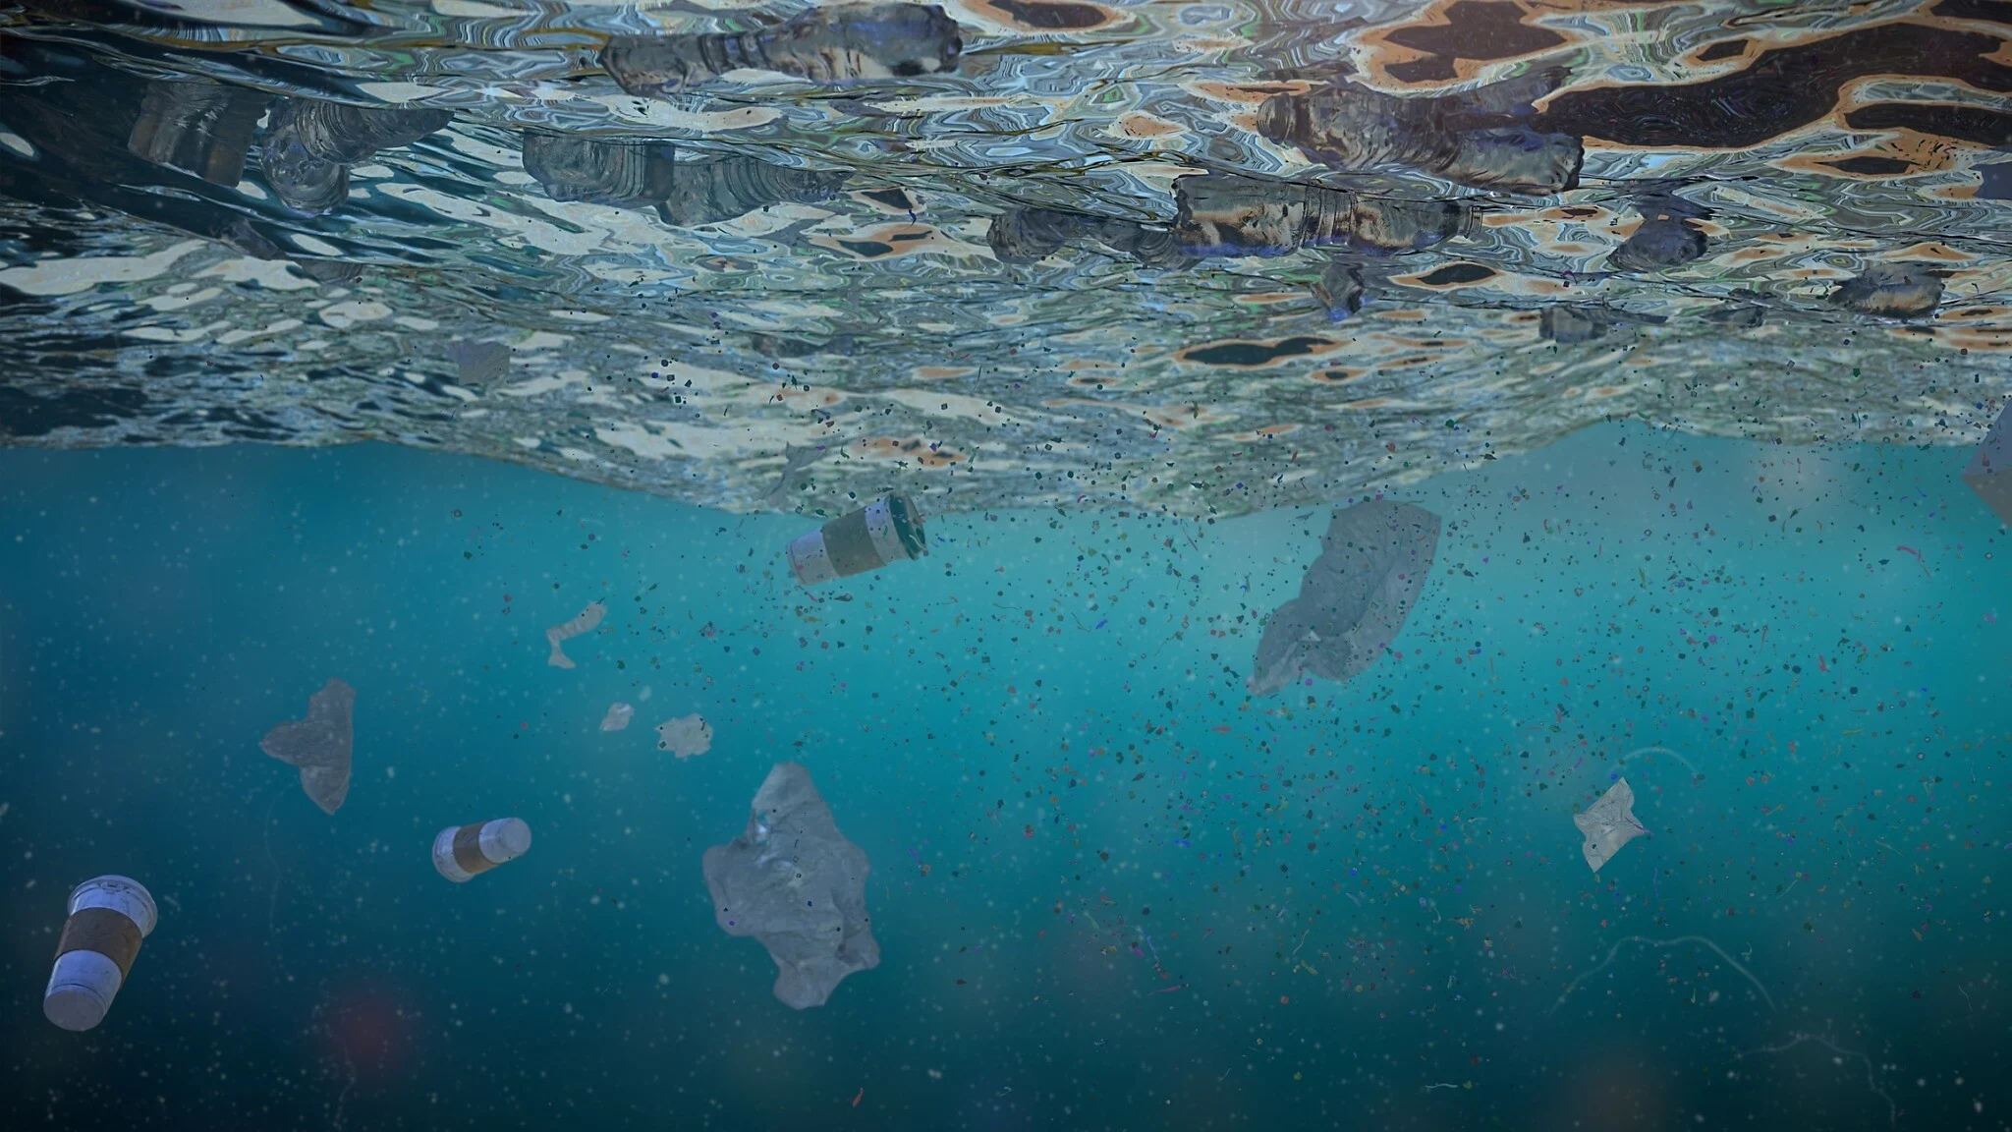

**6. Methodology.**

Two distinct deep learning architectures were employed in this study: a tailored Convolutional Neural Network (CNN) and a ResNet50 model that incorporated transfer learning techniques. The CNN was constructed using fundamental convolutional layers, max-pooling operations, ReLU activation functions, and dropout regularization methods. This particular model functioned as a benchmark for evaluating performance.

For the ResNet50 model, we used pre-trained ImageNet weights and added custom dense layers for binary classification. The earlier layers were frozen to retain generalized image features, and the top layers were fine-tuned for our data. Data augmentation was done using horizontal flip, rotation, and zoom to make it robust. Training used binary cross entropy as the loss function and the Adam optimizer with a learning rate tuned.

**7. Results and Evaluation** Both models were evaluated based on metrics including accuracy, F1-score, and confusion matrix. ResNet50 outperformed the custom CNN with a validation accuracy of around 75% compared to CNN's 72%. Its confusion matrix also yielded more balanced precision and recall for both classes, i.e., it had fewer false negatives and false positives.

The CNN, though faster and simpler, was plagued by misclassifications due to its shallow depth and lack of feature extraction power. Still, it was a good benchmark and gave insightful information on which features were harder for shallow models to pick up on. Plots of training accuracy and confusion matrices helped to further highlight the advantages of deeper architectures on noisy, real-world data.

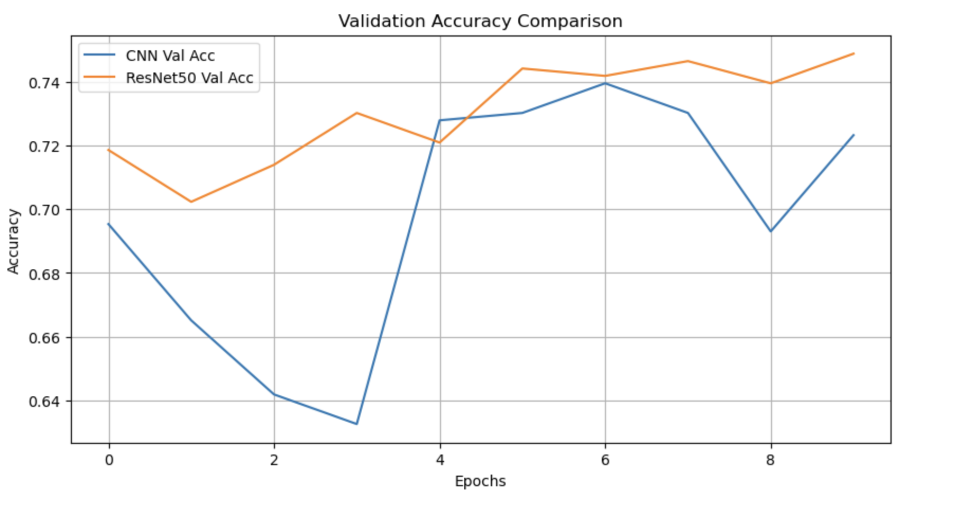

Confusion matrix for CNN: 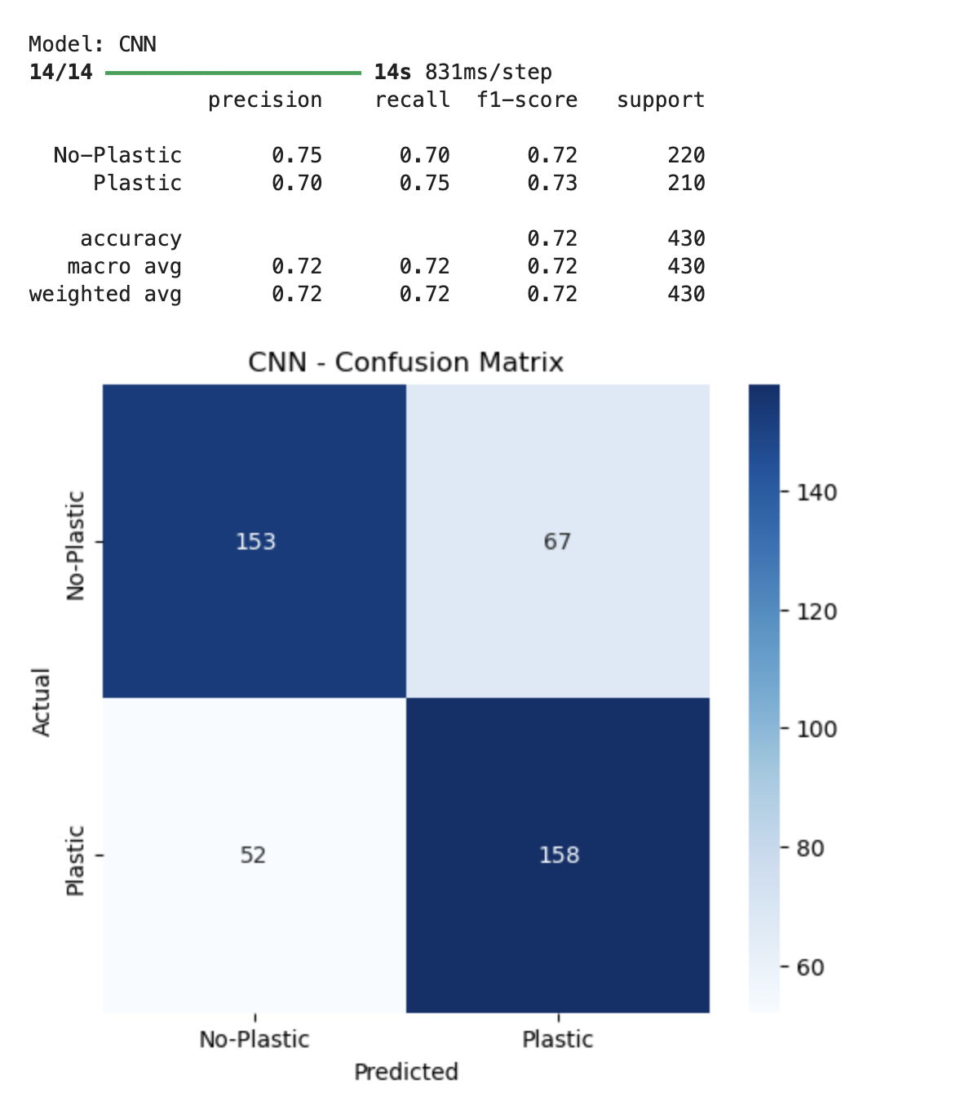

Confusion matrix for ResNet50:

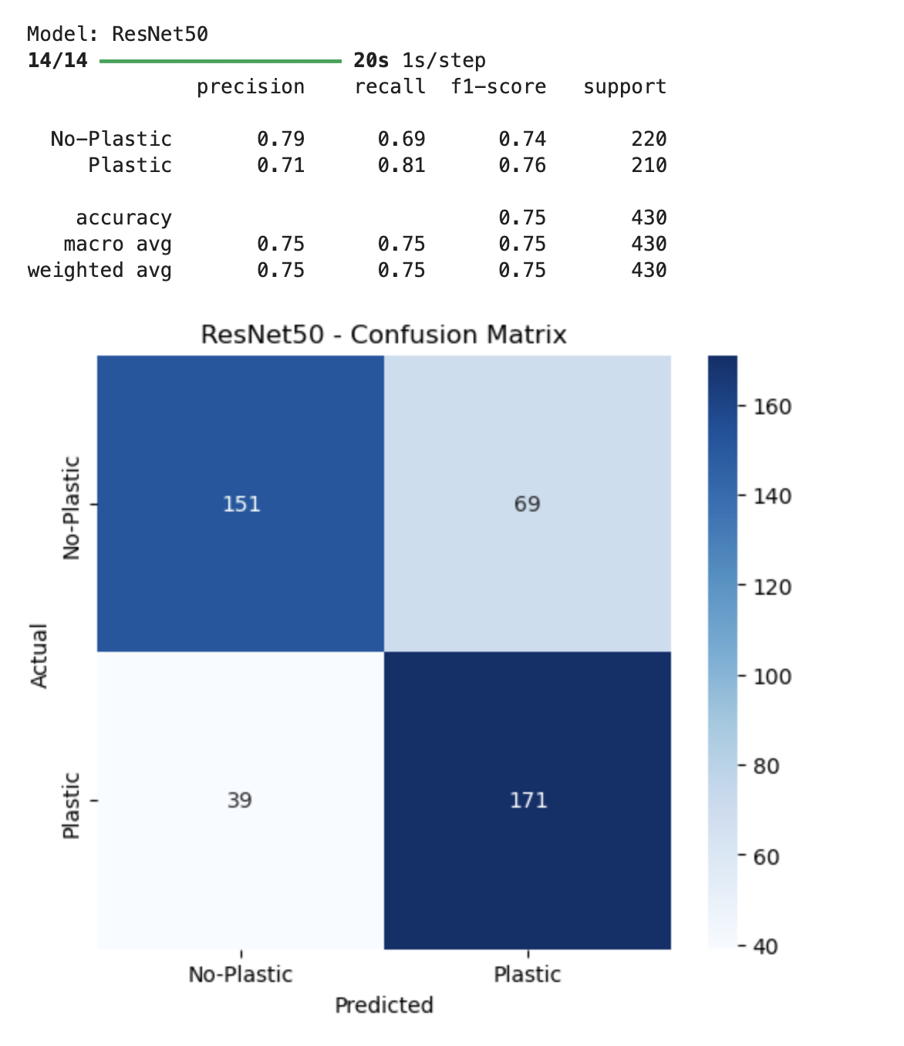

# 8. Conclusion

This project has successfully demonstrated the potential of deep learning techniques for tackling real-world environmental issues, namely the identification of underwater plastic debris. By implementing and comparing our own CNN and a transfer learning approach with ResNet50, we were able to experiment with the efficacy and limitations of both approaches. The ResNet50 model with pre-trained weights from ImageNet was much more effective at extracting and interpreting challenging features from tough underwater images. This attests to the applicability of transfer learning where data is scarce or difficult to obtain. Apart from model performance, this work brings out greater implications of harnessing artificial intelligence in addressing sustainability issues.

Automated plastic classification of underwater images has the potential to accelerate environmental monitoring and support marine conservation efforts with timely, scalable information. There remain several challenges to be tackled, such as dealing with class imbalance, improving detection under visually confusing circumstances, and improving model robustness across diverse aquatic environments. Future directions include expanding the dataset, integrating real-time detection in underwater drones, and experimenting with newer architectures like Vision Transformers or lightweight CNNs for edge deployment. Overall, this project provides a good starting point for the continued use of AI in environmental monitoring and marine conservation.

**9. References**

-K. He, X. Zhang, S. Ren and J. Sun, "Deep residual learning for image recognition", *Proc. IEEE Conf. Comput. Vis. Pattern Recognit.*, pp. 770-778, 2016.

- M. Valdenegro-Toro, "Deep neural networks for marine debris detection in sonar images", 2019, [online] Available: https://arxiv.org/abs/1905.05241.- TensorFlow, Scikit-learn Documentation

- H.-T. Nguyen, E.-H. Lee and S. Lee, "Study on the classification performance of underwater sonar image classification based on convolutional neural networks for detecting a submerged human body", *Sensors*, vol. 20, no. 1, Jan. 2020.

- G. Huo, Z. Wu and J. Li, "Underwater object classification in sidescan sonar images using deep transfer learning and semisynthetic training data", *IEEE Access*, vol. 8, pp. 47407-47418, 2020.

- K. Topouzelis, D. Papageorgiou, A. Karagaitanakis, A. Papakonstantinou and M. A. Ballesteros, "Plastic litter project 2019: Exploring the detection of floating plastic litter using drones and Sentinel 2 satellite images", *Proc. IEEE Int. Geosci. Remote Sens. Symp.*, pp. 6329-6332, 2020.

- K. Themistocleous, C. Papoutsa, S. Michaelides and D. Hadjimitsis, "Investigating detection of floating plastic litter from space using Sentinel-2 imagery", *Remote Sens.*, vol. 12, no. 16, Aug. 2020.

- S. Kako, S. Morita and T. Taneda, "Estimation of plastic marine debris volumes on beaches using unmanned aerial vehicles and image processing based on deep learning", *Mar. Pollut. Bull.*, vol. 155, Jun. 2020.

- M. Fulton, J. Hong, M. J. Islam and J. Sattar, "Robotic detection of marine litter using deep visual detection models", *Proc. Int. Conf. Robot. Autom.*, pp. 5752-5758, 2019.

- Xinjie Li, Guojia Hou, Kunqian Li, Zhenkuan Pan, "Enhancing underwater image via adaptive color and contrast enhancement, and denoising", *Engineering Applications of Artificial Intelligence*, vol.111, pp.104759, 2022.   
- Tianlong Jia, Zoran Kapelan, Rinze de Vries, Paul Vriend, Eric Copius Peereboom, Imke Okkerman, Riccardo Taormina, "Deep learning for detecting macroplastic litter in water bodies: A review", *Water Research*, vol.231, pp.119632, 2023.